South Florida Growth Geographies: Data Summary
KTAF 2030 growth planning · June 2026 · Source: KIPP Demographics tool (Miami-Dade & Broward) unless noted
This summary covers the three targeted geographies for KTAF growth in South Florida: Miami-Dade Central (M-DCPS Board District 2 / Greater Liberty City), Miami-Dade South (M-DCPS Board District 9 / Greater Homestead), and Broward Central (BCPS Board District 5 / Greater Lauderhill). All three rank at or near the top of their county on the tool’s suitability score, and all three show a consistent pattern: modest overall population growth, a large but shrinking K–8 population, and district-run enrollment declining faster than charter enrollment.

County context
 | Broward County | Miami-Dade County
Population, April 2020 (Census) | 1,944,376 | 2,701,762
Population, July 2025 (Census est.) | 2,013,317 | 2,802,029
Actual growth, 2020–2025 | +68,941 (+3.5%) | +100,267 (+3.7%)
Projected population, 2030 (tool) | 1,980,057 | 2,700,504
Projected growth, 2025–2030 | +15,697 (+0.8%) | +504 (≈0.0%)
Both counties grew solidly from 2020 to 2025, with the Census series suggesting most of that growth came earlier in the period. The tool projects near-flat growth through 2030 — and the school-age slice is projected to shrink outright: K–4 population down roughly 10% and grades 5–8 down roughly 14% in both counties by 2030. The planning implication is direct: enrollment growth in South Florida will come from market share, not market growth.

The three target geographies
 | Broward Central  BCPS D5 | Miami-Dade Central  M-DCPS D2 | Miami-Dade South  M-DCPS D9
Anchor communities | Greater Lauderhill | Greater Liberty City | Greater Homestead
Population, 2025 (proj.) | 284,811 | 312,372 | 319,090
Recent growth, 2023→2025* | +3,079 (+1.1%) | +1,855 (+0.6%) | +3,810 (+1.2%)
Projected growth, 2025–2030 | +3,168 (+1.1%) | +684 (+0.2%) | +3,229 (+1.0%)
K–8 population (2023 ACS) | 34,275 | 33,902 | 43,186
% Black (all ages) | 62.3% | 44.2% | 19.1%
% Hispanic (all ages) | 17.8% | 48.1% | 63.3%
% households under $50k HHI | 45.9% | 52.2% | 33.6%
% households receiving SNAP | 22.4% | 35.3% | 25.0%
Median household income (≈) | $62,100 | $55,700 | $86,300
Suitability score (tool default) | 83.8 · #1 of 7 | 70.0 · #1 of 9 | 67.3 · #2 of 9
* District-level actuals for 2020–2025 are not published (school board districts are not census geographies). “Recent growth” shows the tool’s 2023 ACS baseline against its 2025 projection — the closest available proxy.

What the numbers say about each geography
Broward Central (BCPS D5 / Greater Lauderhill) is the strongest profile in the tool: the #1 suitability score in either county (83.8 of 100), the highest projected population growth rate of the three, a majority-Black community (62%), and nearly half of households under $50k income. Its K–8 population (~34,300) is comparable to Miami-Dade Central’s.
Miami-Dade Central (M-DCPS D2 / Greater Liberty City) ranks #1 of 9 in Miami-Dade on suitability (70.0). It has the highest economic need of the three geographies — 52% of households under $50k and 35% receiving SNAP — but also the flattest population trajectory (+0.2% projected through 2030). It is the one geography where charter enrollment is growing fast (+20% in four years) while district-run enrollment falls.
Miami-Dade South (M-DCPS D9 / Greater Homestead) ranks #2 of 9 in Miami-Dade (67.3). It has the largest K–8 population of the three (~43,200, roughly 26% larger than the other two) and strong projected growth (+1.0%), with a heavily Hispanic population (63%). Income levels are higher and charter saturation is already substantial — charters enroll about 36% of public school students there, versus roughly 11–15% in the other two geographies.

Enrollment: charter vs. district-run, 2021–22 to 2025–26
Public school enrollment is falling in all three geographies, consistent with the countywide school-age decline. The split between district-run and charter schools differs sharply by geography. (The tool’s enrollment series begins in 2021–22; 2020–21 is not available.)
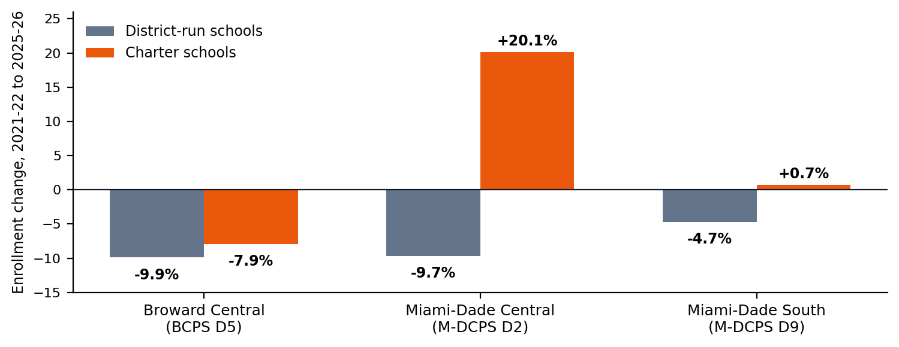
Broward Central (BCPS D5)
 | 2021–22 | 2025–26 | Change (n) | Change (%)
BCPS D5 — District-run (33) | 27,803 | 25,049 | −2,754 | −9.9%
BCPS D5 — Charter (7) | 3,208 | 2,955 | −253 | −7.9%
Miami-Dade Central (M-DCPS D2)
 | 2021–22 | 2025–26 | Change (n) | Change (%)
M-DCPS D2 — District-run (63) | 29,382 | 26,525 | −2,857 | −9.7%
M-DCPS D2 — Charter (13) | 3,976 | 4,775 | +799 | +20.1%
Miami-Dade South (M-DCPS D9)
 | 2021–22 | 2025–26 | Change (n) | Change (%)
M-DCPS D9 — District-run (46) | 32,291 | 30,767 | −1,524 | −4.7%
M-DCPS D9 — Charter (31) | 17,410 | 17,529 | +119 | +0.7%
Read: In D2, families leaving district-run schools are choosing charters — charter seats grew 20% while district-run enrollment fell 10%, pointing to unmet demand for alternatives. In D5, both sectors shrank, so a new school’s case rests on quality and the district’s top suitability fundamentals rather than a rising charter tide. In D9, charters already hold a large, stable share of a bigger K–8 market.

Data notes and gaps
- Counts of schools per sector appear in parentheses in each table. Schools were assigned to board districts by mapping each school’s location against district boundaries in the tool.
- Actual county growth 2020–2025 comes from U.S. Census Bureau Vintage 2025 estimates (census.gov QuickFacts), not the tool — the tool’s baseline is 2023 ACS with 2025/2030 projections. The two series differ slightly (e.g., the tool’s 2025 Broward figure is ~2.5% below the Census estimate).
- Not in the tool: actual 2020–2025 population at the board-district level (not published anywhere; see proxy note on page 1) and 2020–21 enrollment (the tool’s series runs 2021–22 through 2025–26).
- K–8 population is estimated from ACS age bands (ages 5–13), the same approximation used by ESRI and most vendors. Suitability is the tool’s default-weight composite (K–8 population 40 pts, economic need 20, demographics 20, growth 15, total population 5), scored relative to other districts in the same county.
- Charter enrollment in D5 excludes charters just outside the district line (e.g., in neighboring Plantation/Sunrise) that draw D5 families; the tool’s 5-mile-radius view is better for catchment analysis than hard district boundaries.

